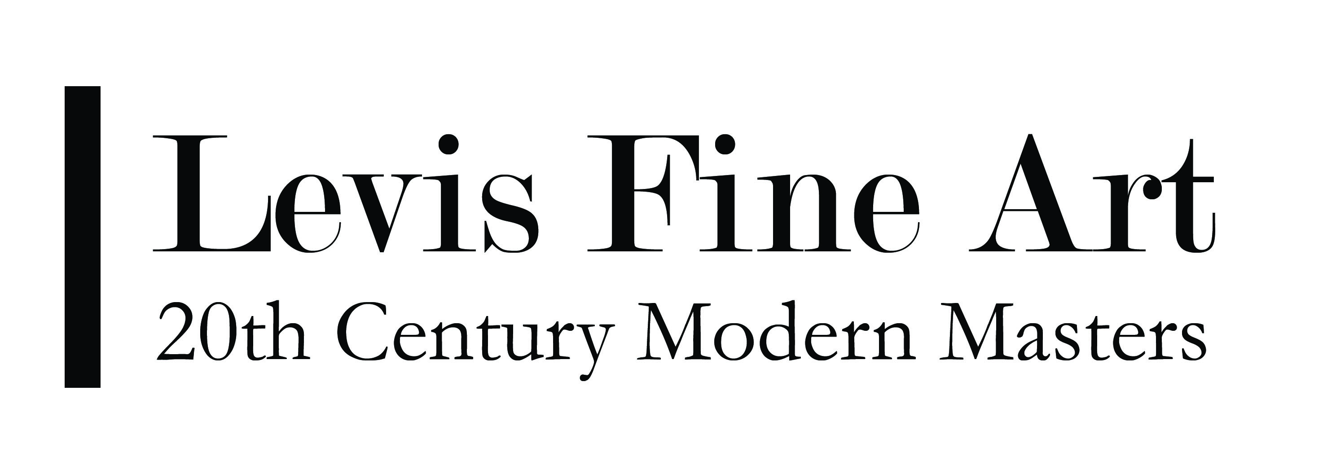

BUDD HOPKINS (1931 - 2011)

A candid reflection on the artistic career of Budd Hopkins reveals a style imbued with the emotional dynamism of the 1950’s, the cool sensibility of the 1960’s, and the linear geometricism of the 1970’s. Works from all points of his illustrious career are in the collection of thirty-two museums including the Guggenheim, The Corcoran Gallery, the Metropolitan Museum of Art and the Whitney.

Hopkins career began during the early stages of Abstract Expressionism, which he embraced with its violent brushstrokes, heavily applied paint and massive canvases. He would often have Franz Kline over to his studio. But by the mid-60’s, Hopkin’s unique style became clear; one in which abstraction finds its place in a color field where there is harmony between angles and circles, blacks with whites, and flatness with depth. This unique style primarily developed from Hopkins’ response to Leger’s later hard-edged works, and also a general increased interest in collages. The collages provided Hopkins with “a method of concretizing the implicit geometries of Abstract Expressionism without sacrificing any of its energy” (Kingsley, 1972)

While the works from the 1960’s reveal a static moment in time, the works from the 1970’s and 80’s reach far beyond a multi-dimensional atmosphere. These works exemplify Hopkins’ ability to transcend movement on a two-dimensional plane, revealing a struggle for “time and attention” within the space.

Hopkins’ oeuvre conveys a sense of uninhibited ‘harmony and life-like complexity’, an intensity that continues to dominate his work today. The duplicitous nature which exists in his canvases pay tremendous homage to Mondrian’s geometric canon, Rothko’s color and depth experiments, and the Abstract Expressionist’s unbridled emotional expressiveness.

© 2009 Levis Fine Art, Inc.

SELECTED ONE-MAN EXHIBITIONS
2010 Levis Fine Art, NY (And 2008, 2006)

2009 Levis Fine Art Modern Masters, Nantucket, MA

2002 Andre Zarre Gallery, N.Y.C. 2001 Castle Hill, Truro Center for the Arts, Truro, MA
1997 Langpoint Gallery, Provincetown,
1990 Korn Gallery, Drew University, Madison, NJ., Sculpture
1988 Marilyn Pearl Gallery, N.Y.C. (And 1985)
Emilsan Gallery, De Pauw University, Greencastle, IN
Jan Cicero Gallery, Chicago, IL
Keystone junior College, La Plume, PA.
Denison University, Granville, OH.
1982 Lemer-Heller Gallery, N.Y.C. (And 1978, 1980,1981).
1981 Fedele Fine Arts, Print Retrospective, N.Y.C.
Coburn Gallery, University of Vermont, Burlington, VT.
1979 Cultural Activities Center, Temple, TX.
1978 Andre Zarre Gallery, Early work, N.Y.C.
Johnson Gallery, Middleburg College, VT.
1977 Pelham-von Stoffler Gallery, Houston, TX
1975 William Zierler Gallery, N.Y.C. (And 1972-1974)
Tirea Kadis Gallery, Provencetown, MA. (And 1958,1960,1962-1974).
Landmark Gallery, Collages. N.Y.C.
1974 Galerie Liatowitsch, Basel Switzerland.
Weatherspoon Art Gallery, University of North Carolina, Greensboro, NC.
Kresge Art Center, Michigan State University, Fast Lansing, MI
1973 Huntington Galleries, Major Retrospective, Huntington WV.
1971 Poindexter Gallery, NYC, (And 1956,1962, 1963, 1966, 1967, 1969)
1968 Philips Exeter Academy, Exeter, NH
1967 Reed College, Portland, OR.
1966 Obelisk Gallery, Boston,
1963 Kasha Herman Gallery, Chicago, IL (And 1962).
1959 Zabriske Gallery, N.Y.C

SELECTED GROUP EXHIBITIONS
2009 Levis Fine Art Modern Masters, Nantucket, MA, “The Fourth Dimension”
2007 Levis Fine Art, NY, Abstract Art at Art 20
2002 Norton Museum of Art, W. Palm Beach, FL, Abstract Paintings from the Collection
2002 Poindexter Collections of American Modernist Painting, Yellowstone
2001 Works On Paper, Inc. Los Angeles, CA (With Mary Heilman and Zaha Hadid) Association and Museum, 1998 Provincetown Art Association and Museum, Provincetown, MA, "Long Point Gallery"

SELECTED MUSEUM AND UNIVERSITY COLLECTIONS
Ackland Art Museum, Chapel Hill, NC.
Allen Memorial Art Museum, Oberlin, Boston Museum of Fine Arts
British Museum, London
Brooklyn Museum of Art, NYC
Carnegie-Mellon Art Museum,
Pittsburgh, PA. Corcoran Gallery, Washington, D.C.
De Cordova Museum, Boston, MA
Delaware Art Museum, Wilmington, DE
Solomon R. Guggenheim Museum, NYC
Joseph Hirshhorn Museum and Sculpture Garden,Washington,D.C. Huntington Galleries, Huntington, WV.
Massachusetts Institute of Technology,Cambridge,MA.
Metropolitan Museum, NYC
Museum of Modem Art, NYC

ARTICLES BY THE ARTIST
New England Review Spring 1997,"Modernism and the Collage.Aesthetic" (Revised version)
Provincetown Arts, Summer 1997, "Remembering Edward Hopper"
Provincetown Arts, June 1986, "The Collages of Fritz Bultman"
Drawing, March-April 1984, "DeKooning's Drawings"
Artforum, Summer 1979, "Franz Kline's Color Abstractions: Remembering and Looking -Afresh"
Art in America, March-April 1978, Contribution to the Cezanne Symposium.
Artforum, March 1977, “Richard Diebenkorn Reconsidered"
Artforum, December 1976, "The New Works of Frank Stella: A Personal Note"
Artforum, Summer 1976, "An As for Ad as Ad: The Collected Writings of Ad Reinhardt”
Communiculture, Summer 1976, "Modernism and the Collage Esthetic"
Artforum, April 1976, "A Note on Composite Imagery-The Photographs of Barbara Jo Revelle."
Artforum, January 1976, Five Reviews: Samªras, Ferret, Lichteinstein, Asbaugh, Grillo, Artforum, Proposal for die –Artforum, March 1975, “ A Proposal for the Museum of Modem Art."
Artforum, March 1975, Letter on Piet Mondrian.

EXHIBITION CATALOGUES AND MONOGRAPHS
Budd Hopkins Paintings-Collages,Cultural Activities Center, Temple, TX, 1979. Text by Robert Motherwell and Charlotte Moser.
Budd Hopkins Assembled Paintings, Lerner-Heller Gallery and Pelham-von Stoffier Gallery, Houston, TX, 1977. Text by Carter Ratcliff
Budd Hopkins Retrospective Exhibition, 1957-1972, Huntington Galleries, Huntington, West, VA 1972. Text by April Kingsley.

Budd Hopkins: Recent Paintings, Obelisk Gallery, Boston, 1966. Text by Brian O'Doherty.

SELECTED ATRICLES AND EXHIBITION REVIEWS
Ashberry, John, Art News, March 1958, Review.
Baur, John I.H., and Goodrich Lloyd, Young America 1960, Praeger, N.Y., 1960.
Brenson, Michael, New York Times July 8,1983, "Sculpture of Summer is in Full Bloom."
Brenson, Michael, New York Times, January 6,1984, Review.
Brenson, Michael, New Y&* Times, January 18,1985, "Six Sculptors Display A Rational Imperative."
Cathcart, Linda L., The Americans: The Collage, Contemporary Arts Museum Houston, TX, 1982.
Frank, Peter, Kresge Art Center Bulletin April 1974, "Budd Hopkins-The Works on Paper"
Frank, Peter, LA Weekly, Art Picks of the Week, July 20, 2001.
Genauer, Emily, New York Herald Tribune, June 2; 1963, ""Acquisitions at the Whitney."
Glueck, Grace, The New York Times, August 1, 1984, "Family: Revived Art on Cape Cod."
Hirshhorm, Joseph, Whitney Review,1961/62, Statement on the Artist.
Kramer, Hilton, The New York Times, Map 13, 1977, Review.
Kramer, Hilton, The New York Times, March 24, 1978, Review.
Lloyd, Ann, The Review, Nov-Dec,1987, "Religion and Art."
McDarrah, Fred, The Artrsts Wor1d, E.P. Dutton, N.Y., 1961
Moser, Charlotte, Houston Chronicle, September 25, 1977.
Motherwell, Robert, Introduction to the Exhibition Catalogue, Cultural Activities Center, Temple TX,1979.
Myers, Terry R, Art Journal, Spring, 1991 Higher Ground The Assembled Paintings Temples, Guardians and Altars of Budd Hopkins
Nemser, Cindy, Arts, March, 1969, Review
O'Doherty, Brian, Object and Idea: An Art Critic's Journal, 1961-67, Simon and Schuster, NY, 1967 “Budd
Hopkins: Master of Movement and Manque."

Perreault, John SoHo Weekly News, May 14,1980, "Altar Buoyant."
Preston, Stuart, The New York Times, September 16, 1956, Review.
Ratcliff, Carter, Art In America, Sept-Oct 1978, Review.
Ratcliff, Carter, Art in America, May 25, 1978, Review.
Rose, Barbara, New York Magazine, May 1, 1972, Review.
Rosenberg, Harold, Art News Annual, 1959, "Tenth Street: A Geography of Modern Art."
Russell, John, The New York Times, February 5,1982, Review.
Russell, John, The New York Times, May 9,1980, Review.
Sawin, Martica, Arts, October 1956, Review.
Schjeldahl, Peter, The Village Voice, September 14,1982, "Spacey Invaders."
Schuyler, James, Art News, February 1959, Review.
Tucker, Marcia, Art News, April 1967, Review.
Tully, Judd, Art/World, May 21,1980, Review.
Tyler, Parker, Art News, November 1956.
Zimmer, William, New York Times (New Jersey Edition)

